Taslim Dosunmu

Geeth Anirudh

System Level Programming

19 September 2017

Lab 4

4. Read each line containing CSC[space]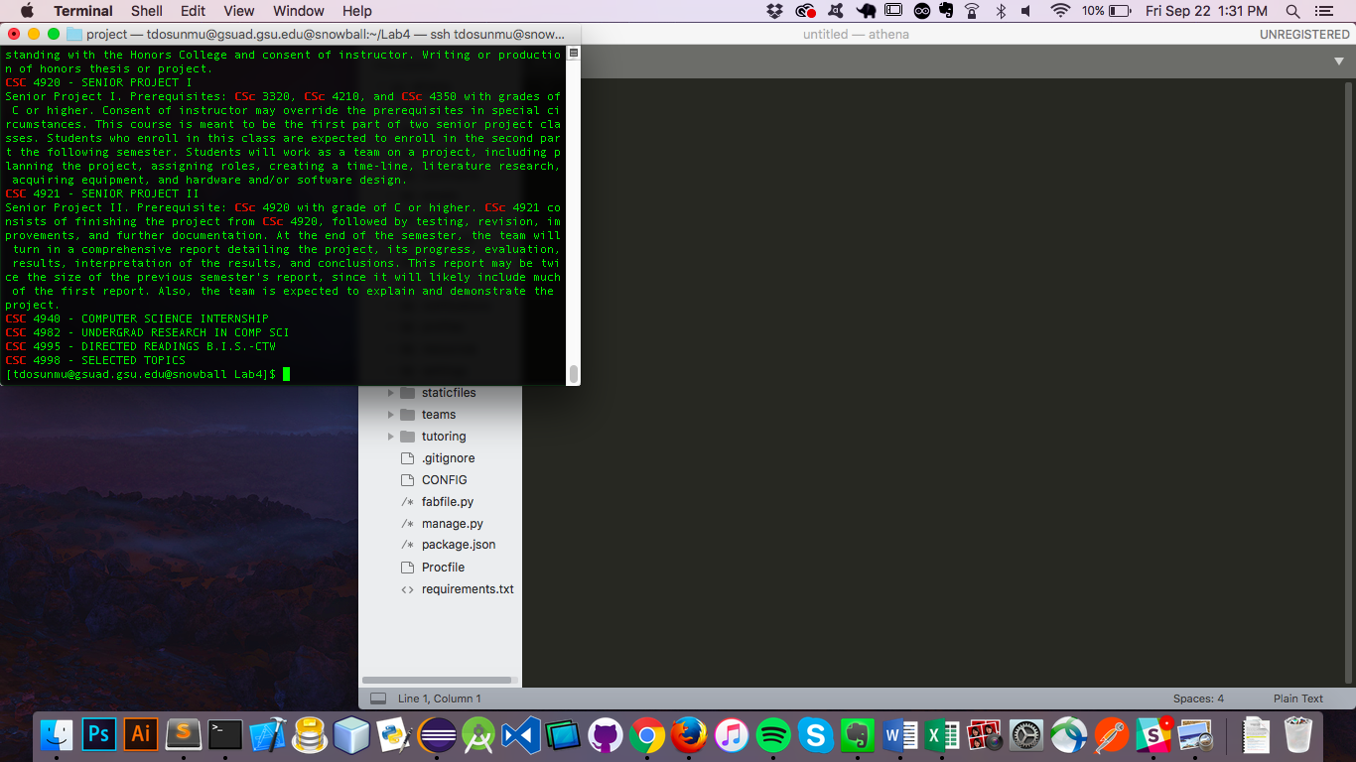

5. Output each line containing CSC 3|CSC 1

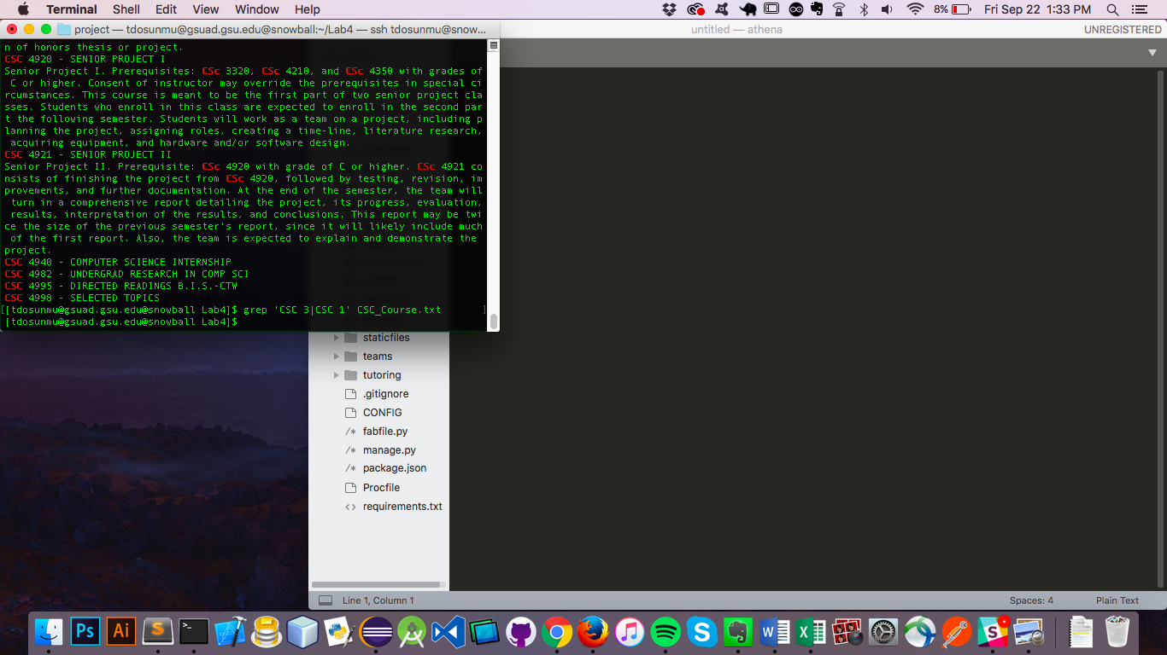

6. Output each line containing CSC 3 or CSC 1

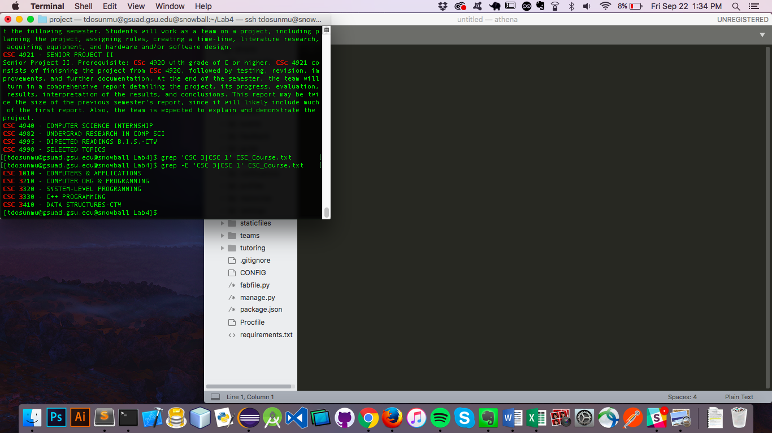

7. use dedicated egrep to output each line containing CSC 3 or CSC 1

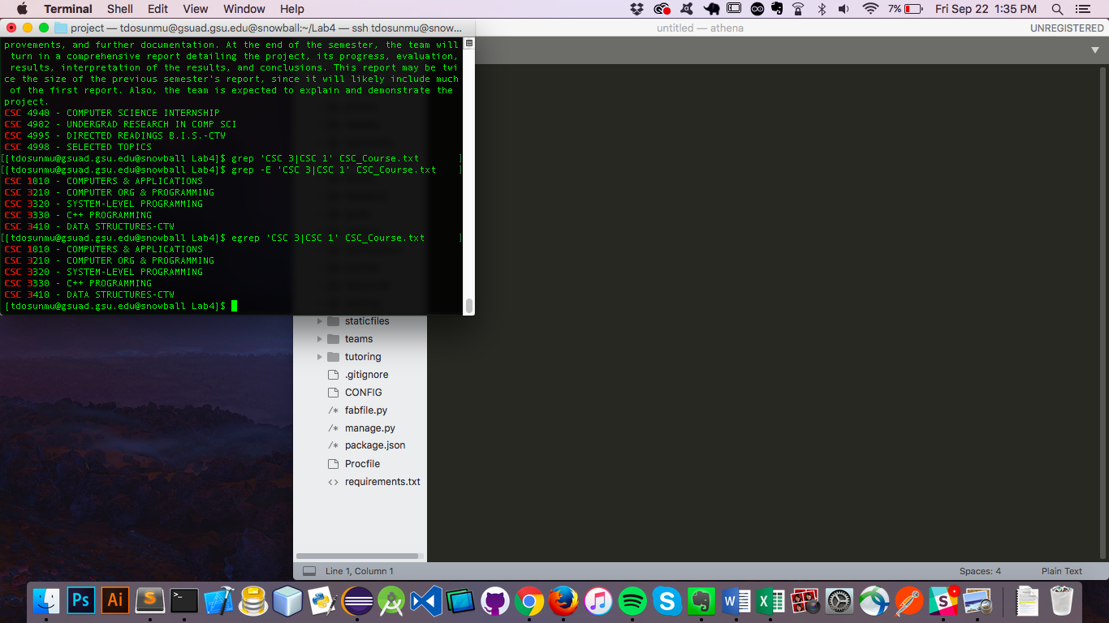

8. Output any lines containing 3.000 Credit hours

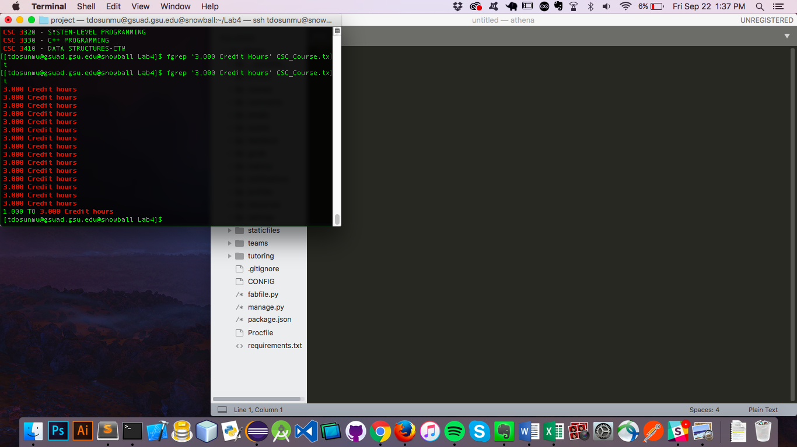

9. output lines starting with 3.000 Credit hours as fixed string

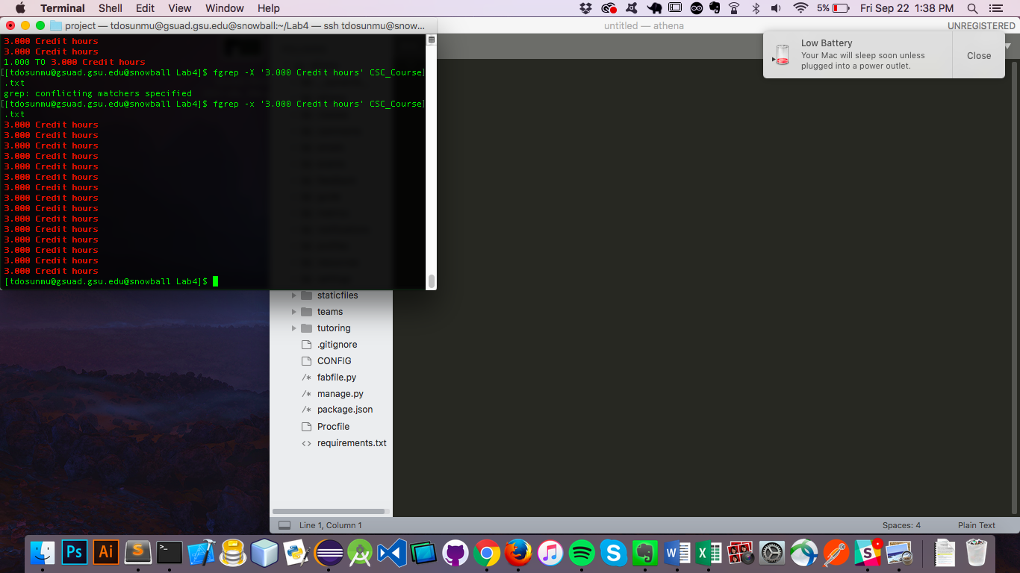

10. output lines containg CSC with any characters between and ending with PROGRAMMING, there can be characters after

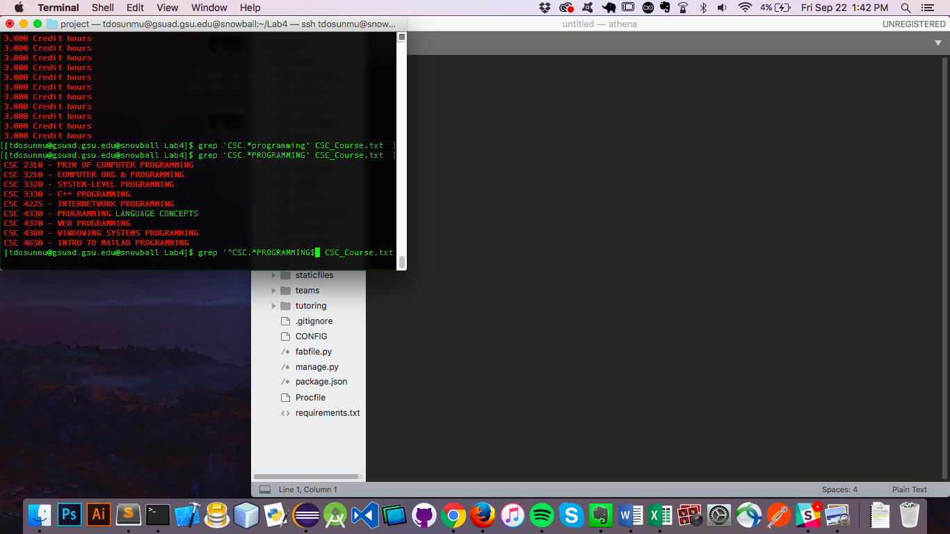

11.output lines starting with CSC and ending with PROGRAMMING

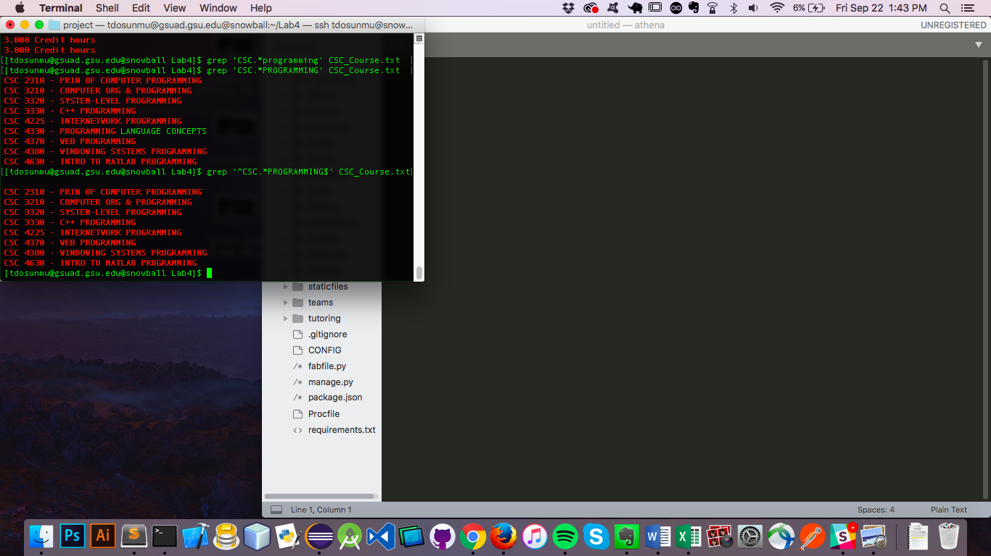

12. match lines containing CSC[^3](any character)3{2}[^3]

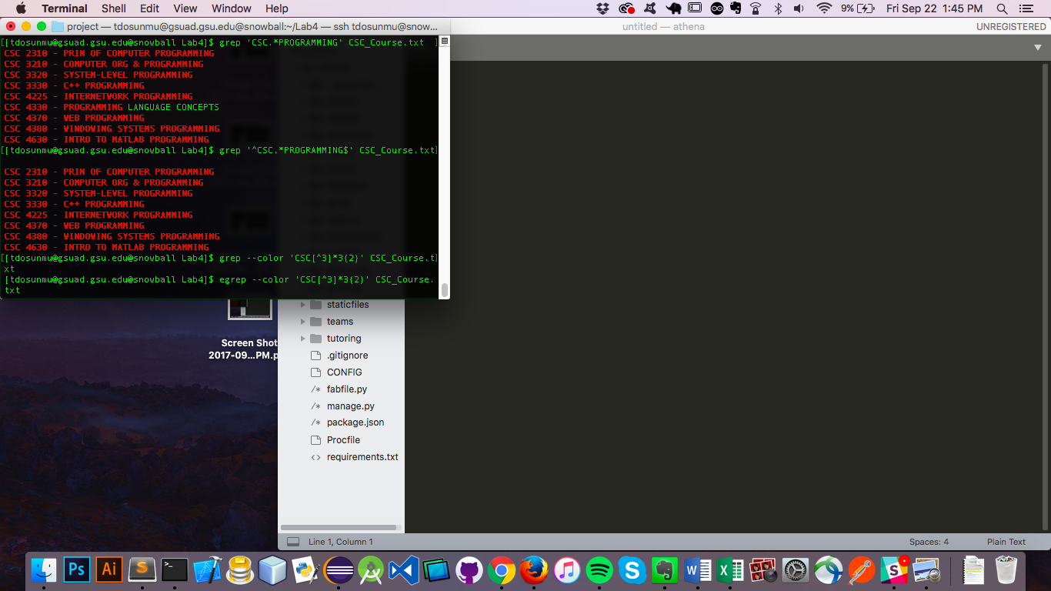

13. output lines containg CSC[not 3]any number of times3[2 times][not 3]any number of times

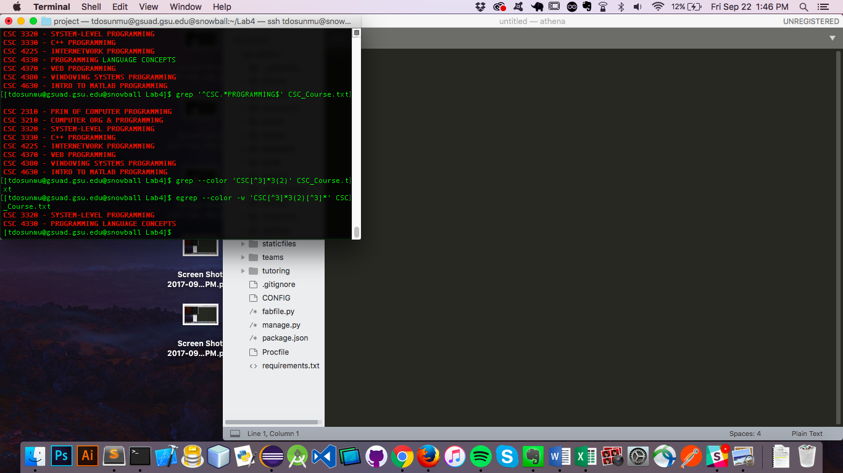

14.output lines containing CSC[any character any number of times]C++

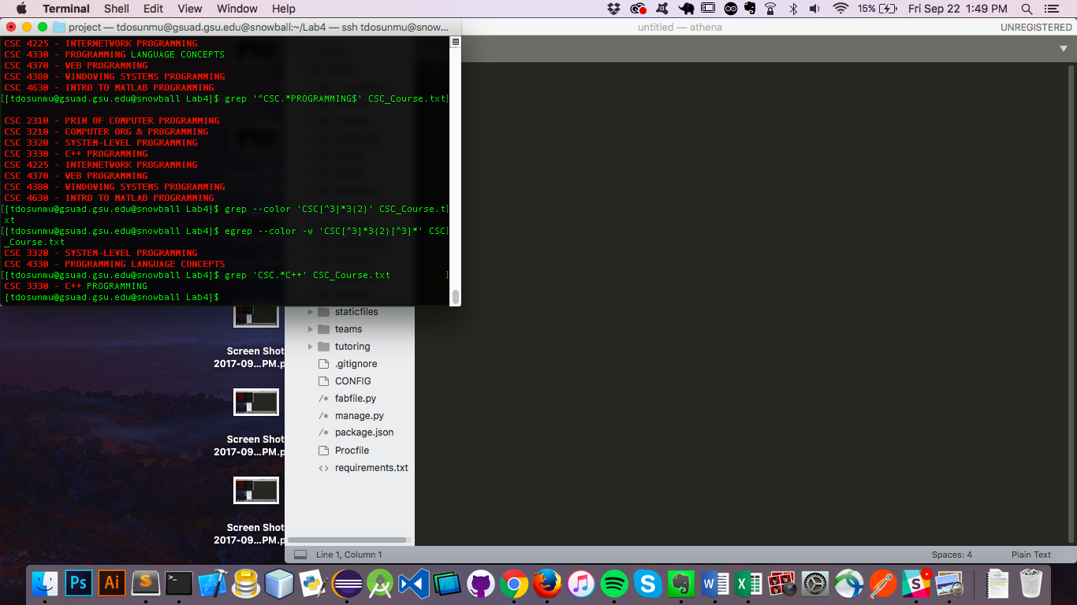

15. output lines containing CSC[any character any number of times]C[escaped +][escaped +]

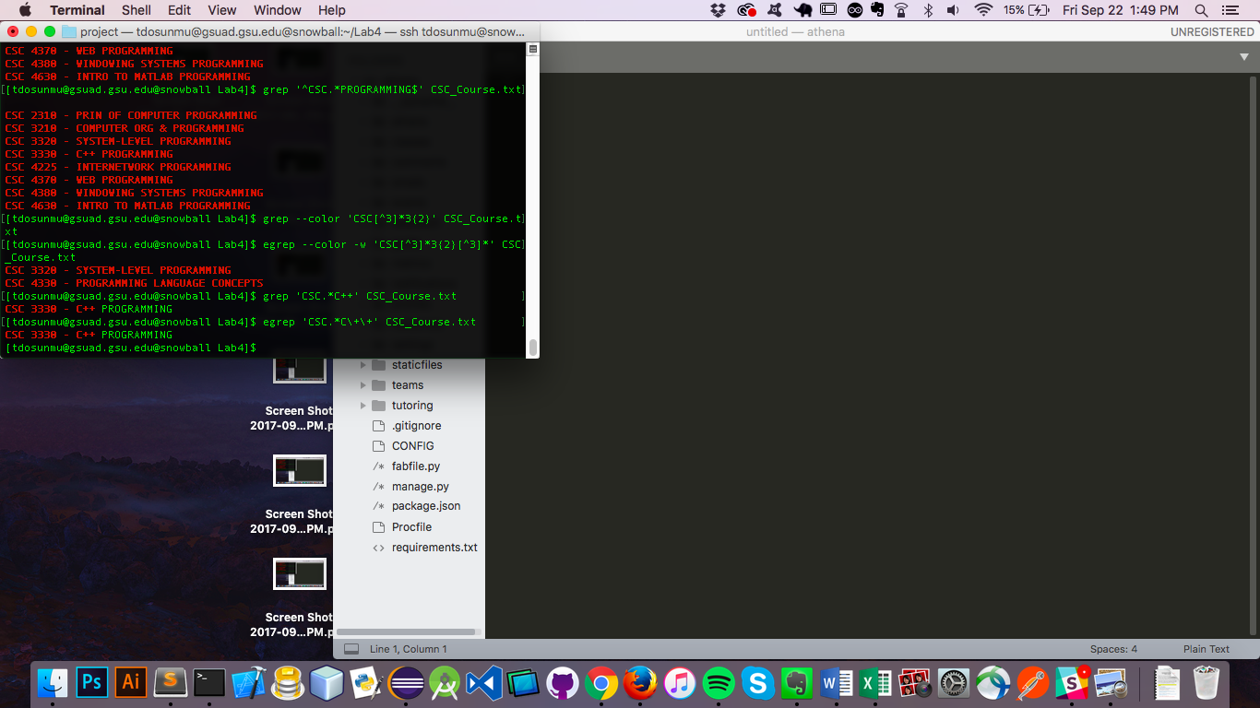

16. Output lines containing CSC[any character any number of times]C[1 or more times]

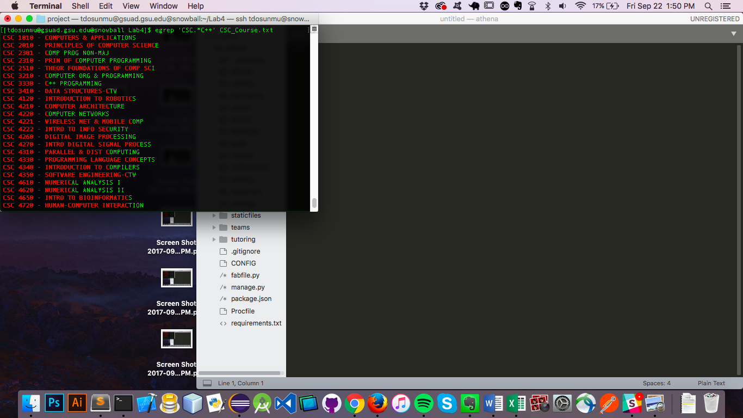

Optional:

1.

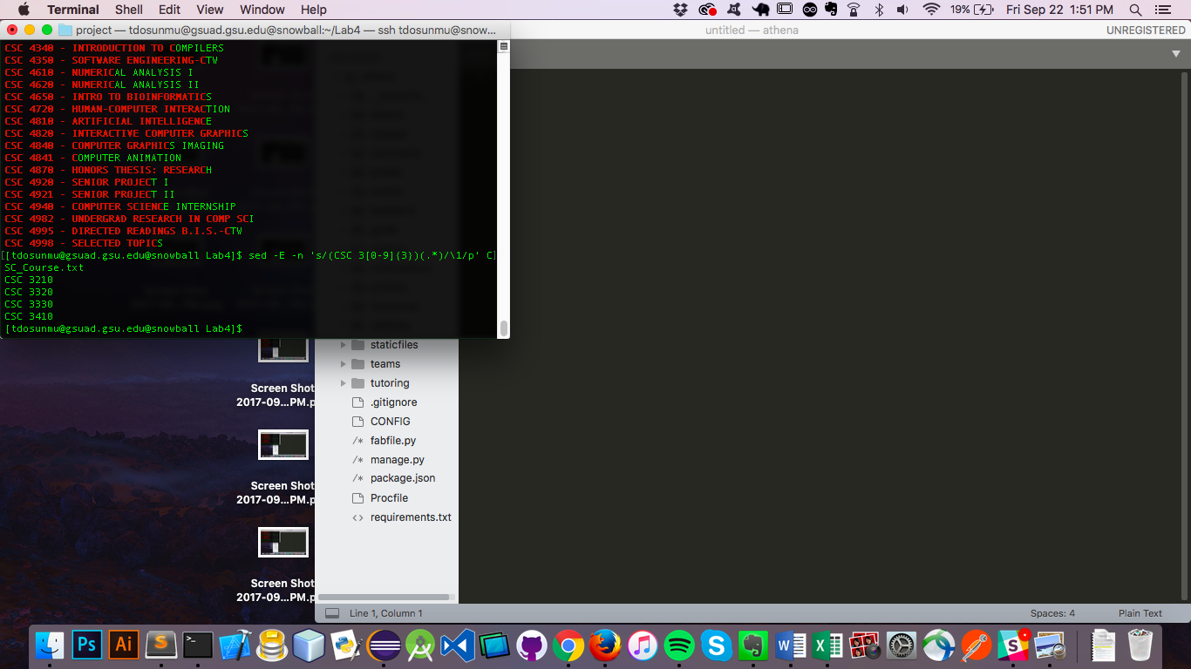

2.

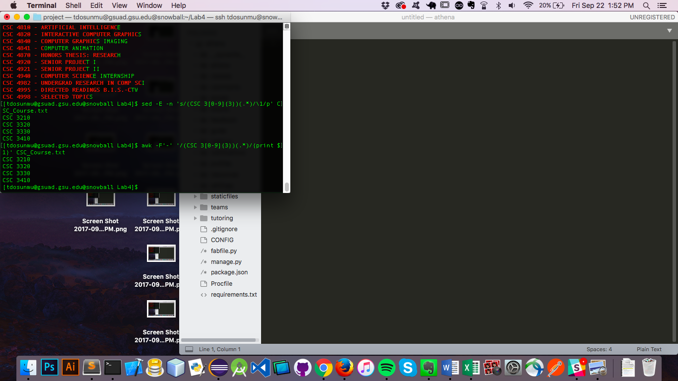

3.

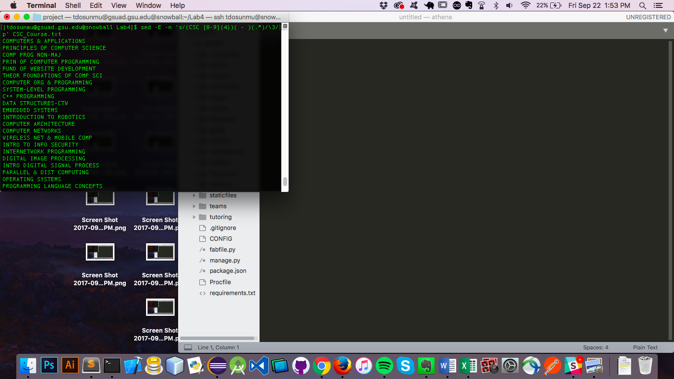

4.

